DSC-Sponsored Finals Relief Salon:
Overwhelmed by the end-of-semester madness? We’ve got your back (for massages, at least). The DSC is sponsoring Finals Relief Stations this fall to help you rest, relax, and refresh while studying, writing, and grading.
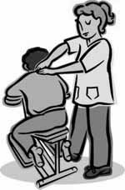
WHO:
All Graduate Center students
WHAT:
Finals Relief Salons with free 10-minute chair massages, earplugs, napping/meditation stations, and handouts on chair yoga and aromatherapy.
WHERE:
Mina Rees Library, First floor beyond the elevators
WHEN:
Tuesday, December 15th, 11am-3pm
Wednesday, December 16th, 11am-3pm

